**School Student Rollback Flow**

**Need to Verify before Rollback**

* Need to Confirm with School Staff to Rollback. There is no Bill for this academic year
* If we did any code change related to fee structure change or new Section/Standard Add, Need to check code in student rollback form
* Take latest database back up in SQL server
* After Started Rollback Process, should not do any other process like bill Pay, Create student,etc.

***Note: Based on Student strength it will take time.***

**Steps toroll back Student**

1. Select->Student-> Student Rollback

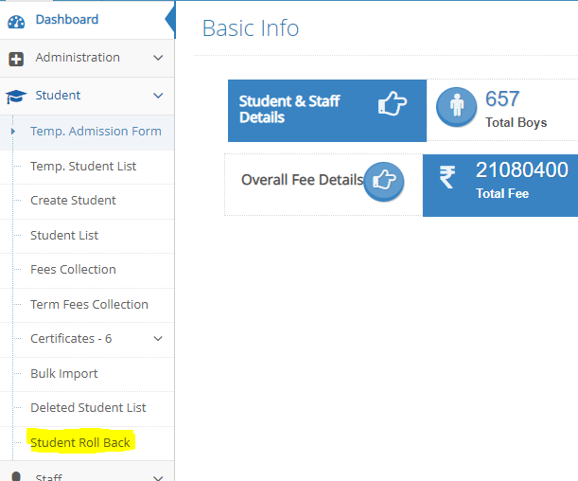

1. Select All Student in Student Roll back form and Scroll down to last

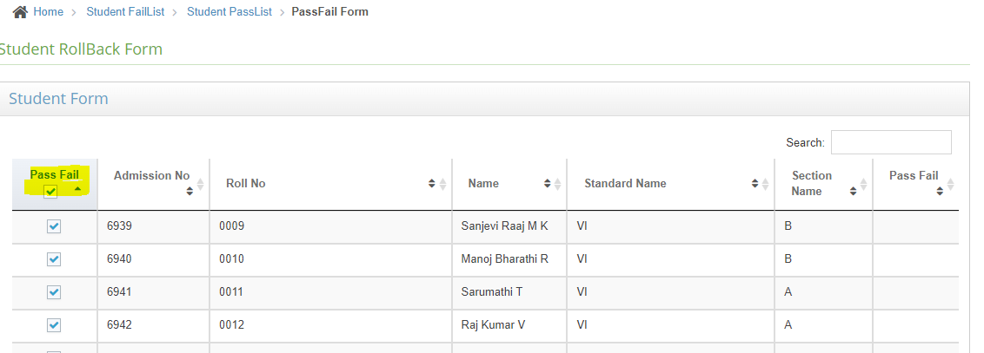

1. Then Scroll down to last and click submit button

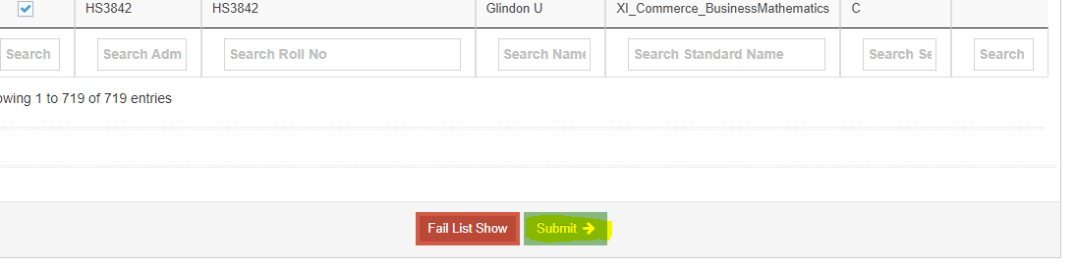

1. Next click on Student Pass List

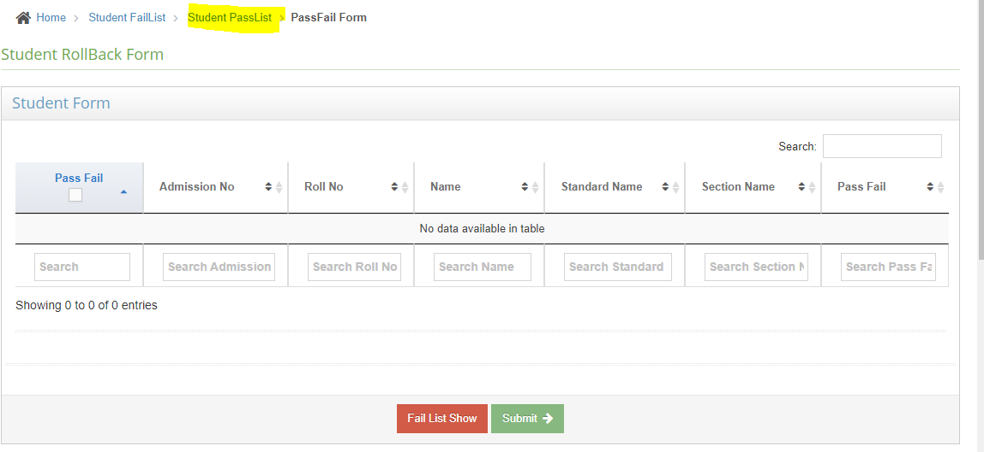

1. Create Academic Year by click on Search button

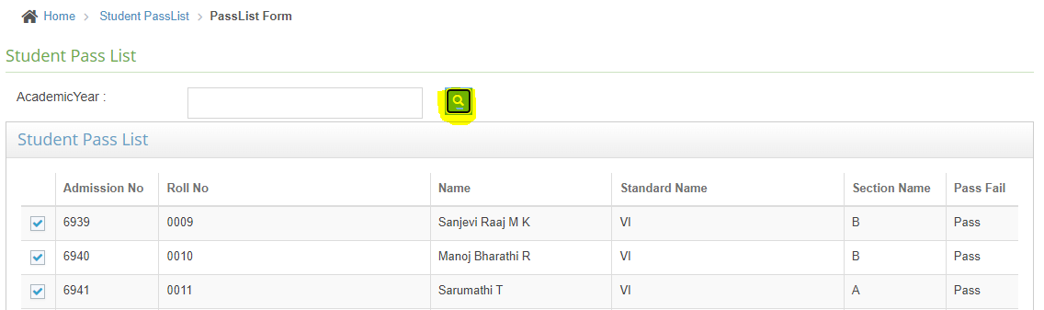

1. Create academic year like this format

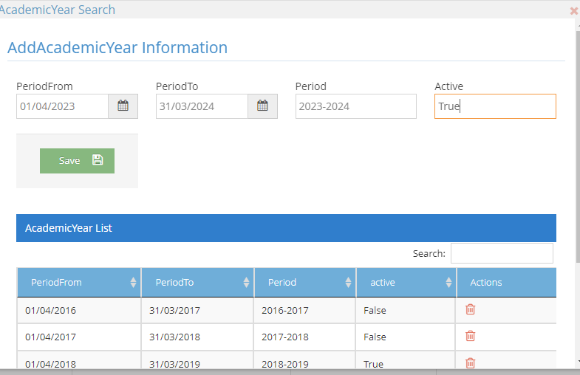

1. After created Academic Year click on row for Which academic year to Move student

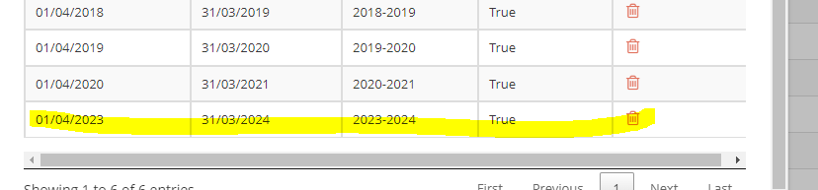

After Chose Academic year(clicked row in table), we will see screen like below

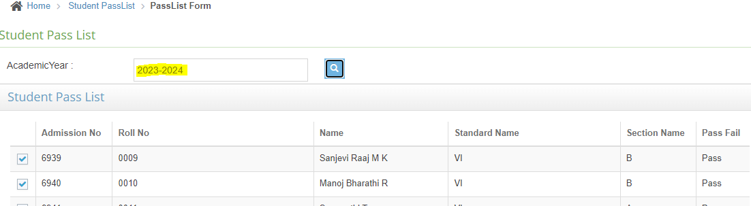

1. Scroll down to bottom and click submit. This is the final step

